**Digitalization**

As part of the Course we could look into developing or at least sketching an action plan on how to proceed with everything that requires IT knowledge. In the following we present two ideas:

## Website

We see reasonable to implement a MVP website for the product. For this purpose we would like to ask you for some content. We will try to put the content ourselves but you should tell us things like how much it should be unrelated to CKJ. It seems like having the name of CKJ would help towards being more trusted towards future stakeholders.

For this purpose we would like to ask you:

* What name for the website/product would you like ?
* Do you have currently a hosting service to host the web ? If not then we should pay for one, we have been looking into a few sites and [inmotion](https://www.inmotionhosting.com/business-hosting) seems like the best for what we want. Would you be willing to pay for the hosting ?
* We would implement the website in English since we are not very proficient in Danish, otherwise, we would need some help in the translation. In this matter any documents about the machine or that you want to include would be helpful. Initially we can work with what we already have.

The website would help us to:

* Seem more professional to the stakeholders
* Maybe we could use it in a basic version of sending and displaying data from the machine.

## Digitalization of the Machine

A recurrent wish that we have from you is to digitalize the machine. We thought that the ideal approach would be to create a system that:

* Measure the values of the sensors every second or so.
* Sends the information to a server.
* The information can be accessed on real time via webapp.
* It can generate the report from the measurements.

We created the following schematic:

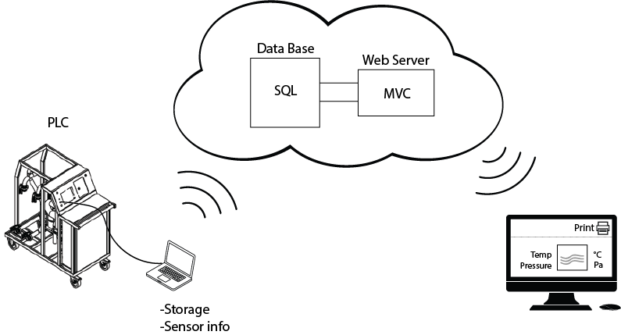

The technologies used for the Database and Web Server can be modified, a first approach would be to:

* Modify the PLC code to perform measurements of the sensors every second.
* Send the measurements to a computer connect by Ethernet.
* Send the Recordings to a Server via Wifi. The DDBB could run on MySQL for example.
* Create a website, for example based on Model-View-Controller technology, ASP.NET that would read the data from the DDBB and display it, probably with the library Highcharts.

For this purpose we could use the website as an initial playground to display the information. We do not have many IT resources so we are trying to hire a new student into the team, although we see that it is unlikely at this point, we will try.

Initially the goal would be to be able to visualize the measurements from the website.

Making the system commercial would require to:

* Add secure Login for the Users.
* Create a structure in the database to allow the differentiation between different cleaning instances of the different clients allowing them to check previous implementations.
* Possibility of downloading a pdf version with analysis of the cleaning process.

As we said, if we do not have IT resources is unlikely to create the system during this Course but it is an starting point on what we would like to have. This company that create the PLC code, would you be willing to use them again or similar for modifications ?